AI Assisted Coding
Lab test:04
2403A533056
Q:1
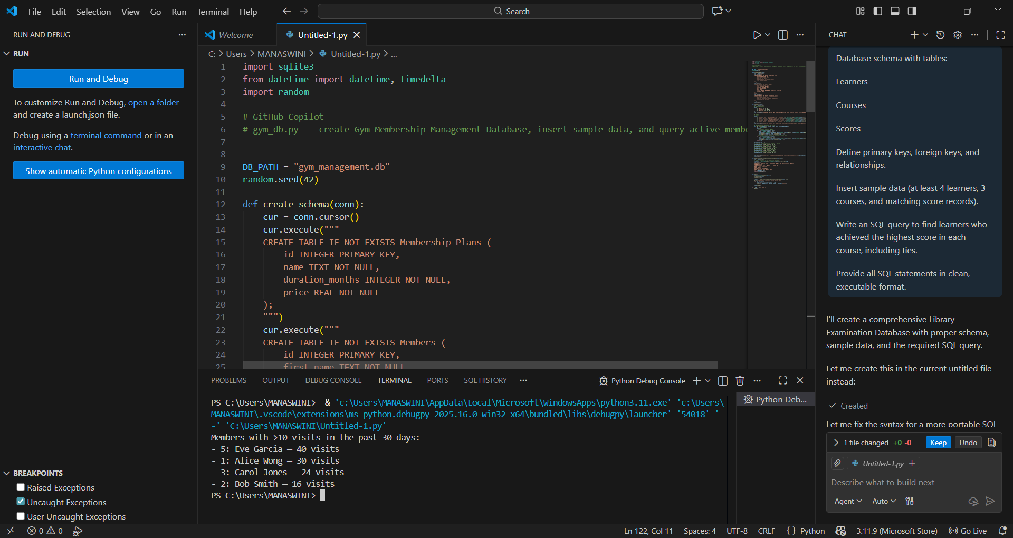
Q:2
